Power Bi Assignment 2

1. Explain the advantages of Natural Queries in Power Bi with an example?

a. Q&A enables Natural language querying, where in end user can ask questions in English to get the resultant report.

b. Querying becomes easy as there is not need of knowledge on any other querying languages like SQL, MySql etc.

c. Auto-complete feature helps users to select relevant query or fill in the query.

d. Q&A identifies the words while typing and underlines the words with colours when matched with a field or value in the data model

e. As you type in, Q&A can produce visualization by taking relevant fields into the proper axis.

Example: show me top 10 products by sales

show me sales growth in last quarter

2. Explain Web Front End (WFE) cluster from Power BI Service Architecture?

The Architecture of Power BI service is based on 2 Clusters,

1. Web Front End (WFE) cluster which handles the initial connections & authentication to PBI service.

2. Bank end cluster which handles the subsequent interactions.

PBI service uses Azure Active Directory(AAD) to manage mange user identities, AAD manages storage in Azure Blob & meta data into SQL database.

PBI uses Azure Traffic manager to direct the traffic to nearest datacentre. This traffic manager uses DNS record of client trying to connect, authenticate and download any files or static content.

Azure Content Delivery network (CDN) help Power BI to efficiently distribute the static content & files based on user location.

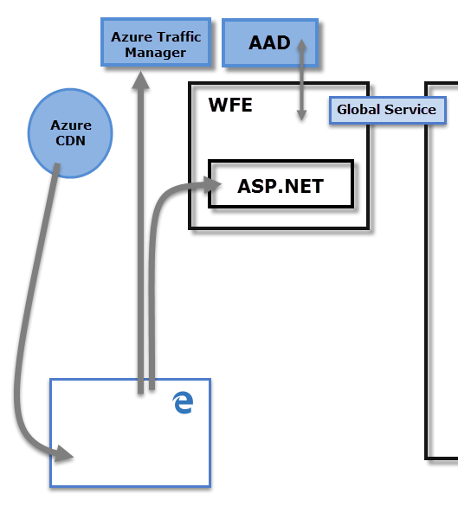

3. Explain Back End cluster from Power BI Service Architecture?

The Back-End cluster manages visualizations, user dashboards, datasets, reports, data storage, data connections, data refresh, and other aspects of interacting with the Power BI service.

Back end cluster decides how the authenticated clients interact with PBI service.

Users cannot directly interact with other roles than Gateway Role. Gateway Role act as a gateway between user requests & PBI Service.

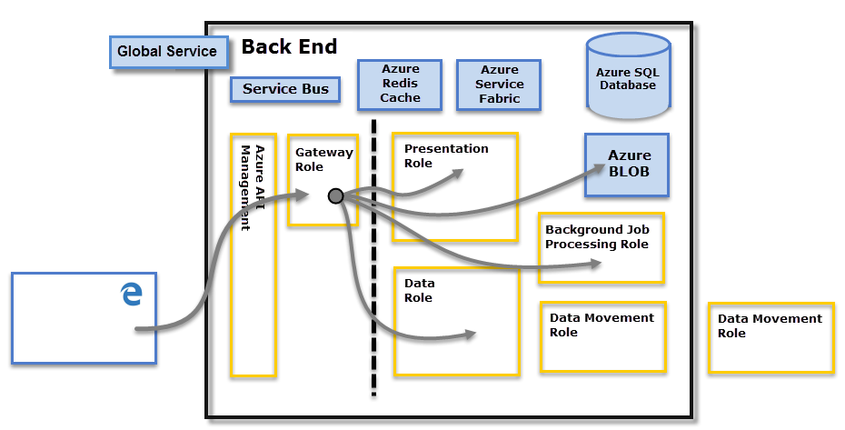

4. What ASP.NET component does in Power BI Service Architecture?

A WFE cluster consists of an ASP.NET website running in the Azure App Service Environment (an Azure App Service feature that provides a fully isolated and dedicated environment for securely running App Service apps at high scale.). When users attempt to connect to the Power BI service, the client's DNS service may communicate with the Azure Traffic Manager to find the most appropriate (usually nearest) data center with a Power BI deployment.

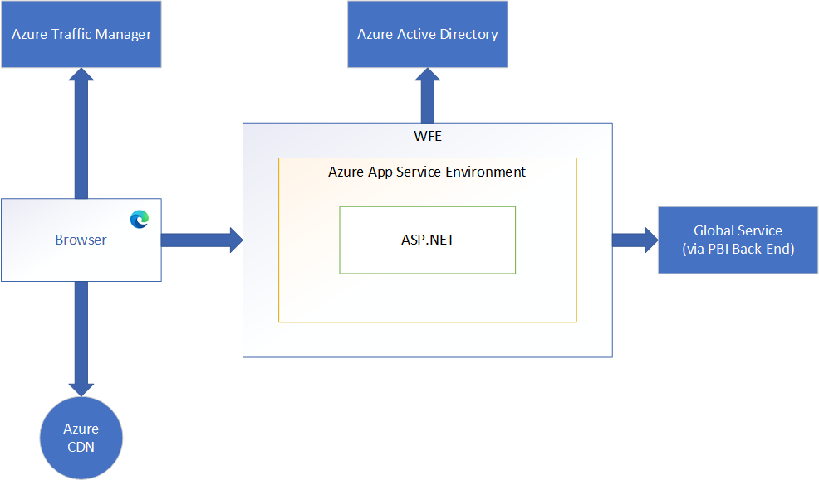

5. Compare Microsoft Excel and Power Bi Desktop on the following features:

|  |  |  |
| --- | --- | --- |
| **Features** | **Power BI** | **Excel** |
| Data import | Supports 80 different data sources from which data can be imported. | Supports around 40 different data sources |
| Data transformation | Power query helps in transforming data. | Data can be transformed in native excel app or can also use Power Query editor in Excel. |
| Modelling | Power BI is really focused on data ingest and building potentially complex data models easily. | Excel is focused on structured and simple data models with a wide range of features. |
| Reporting | Power BI offers visually appealing yet dynamic insight reports comparing excel. | Excel reports are normal and typical comparing Power BI. |
| Server Deployment | Reports can be published to power BI Service using inbuild Publish feature | Supports Co-Authoring for which the file needs to be saved in any cloud platform like OneDrive, Azure, SharePoint etc. |
| Convert Models | Power BI is equipped with Power Query which automatically detects data and convert into Data Models by building Relationships between tables. | Power query is available in Excel 2013 and above by default, previous versions can get it by adding it as Add-In, which works |
| Cost | Power BI is free to download and use for personal use, but it takes $10 per month per customer to share reports with others. | Need to buy licence and Users need to spend any added amount to procure and build dashboards. |

6. List 20 data sources supported by Power Bi desktop.

1. Text/CSV 11. MySql Database

2. Excel 12. PostgreSQL Database

3. JSON 13. Amazon Redshift

4. XML 14. Snowflake

5. SQL Server Database 15. Azure Blob

6. Access Database 16. Power Bi Datasets

7. SSAS Database 17. SharePoint List

8. Oracle Database 18. Python Script

9. IBM Db2 Database 19. Google Analytics

10. IBM Netezza 20. Git Hub